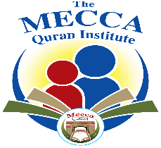
MQI Rules and Regulations

1) I authorize the Mecca Quran Institute (MQI) staff to provide my child with any Emergency Medical Care on site, including transferring him/her to a nearby emergency facility, when I or my spouse cannot be reached. I will be responsible for any medical charges.
2) I authorize the Mecca Quran Institute (MQI) staff to photograph or videotape my child in any activities and to use photographs and videos in presentations or other promotional material.
3) I authorize my child to participate in any activity that may be hosted by private or public transportation *(any activity that requires leaving the premises of the center will be notified by another slip)
4) My registration is not complete and my spot is not reserved until I pay a minimum of $50 registration fee per child, this is a continuous program, no refunds on missing school days. Please email mqi@meccacenter.org if you would like to cancel your registration, use (cancelation) in the subject line.
5) Payments are due on the 7th of each month. To update your payment information, please use the parent payment portal.
6) The Mecca Quran Institute (MQI) will not be liable under any circumstances in case a student develops COVID-19 if on-site classes resume.
7) All students must follow our dress code online (dress to impress). For girls, head scarfs with covered tops, for boys proper t-shirts or dress shirts. Appropriate Islamic attire must be worn on-site.
8) All students need to be in a school setting behind a desk or setting in front of a wall for less distractions and to be ready for class.
9) Any absence must be reported to the student’s teacher.

